BU Memo Senior Design ENG EC 463



To: Alan Pisano, Osama Alshaykh, Babak Kia

From: John McCullough, Shantanu Bobhate, Brian Tan, Bandhan Zishanuzzaman, Teng Zhang

Team: 2 aka Right Alert

Date: 4/14/2016

Subject: **Functional Test Report**

**1.0 Equipment and Setup**

**1.1 Equipment**

The RightAlert system consists of four blocks at its highest level. These blocks are the RightAlert hardware hub, the LED lit alert sign, a solar panel, and the RightAlert website. For this test, all were present except the solar panel.

The RightAlert hardware hub is a weather-proof enclosure made of ABS plastic which contains :

1. NVIDIA Jetson TK1 running the bike detection algorithm
2. ELP 1080x960 Hd 2.8-12mm Varifocal Lens USB Webcam
3. Venom 12V 6400 mAH Lipo Battery
4. Current sensor which monitors battery level
5. Relay circuit controlling the alert sign
6. Charge controller orchestrating the charging of the battery and powering of the sign
7. USB Wi-fi dongle

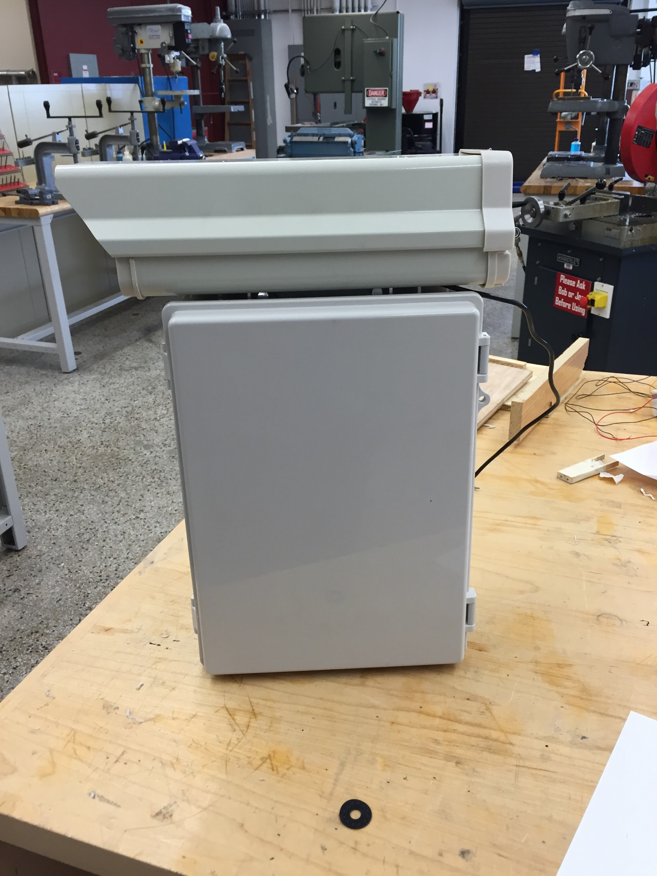 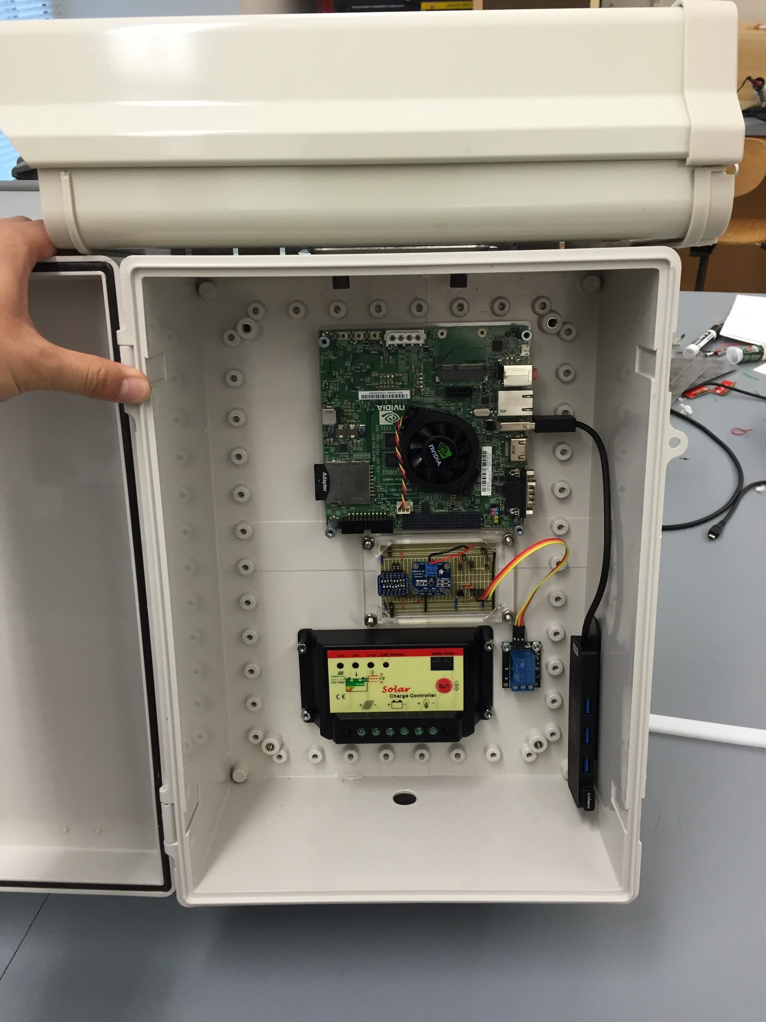

Figure 1. Exterior of hardware hub Figure 2. Interior of hardware hub. Battery is

missing from this picture

Inside the plastic enclosure, the soldered circuit board contains the appropriate connections for the current sensor and relay to function. Wires are connected between the circuit and the Jetson from female header pins on the circuit board to the GPIO ports of the Jetson. Below are two diagrams displaying how to make these connections.

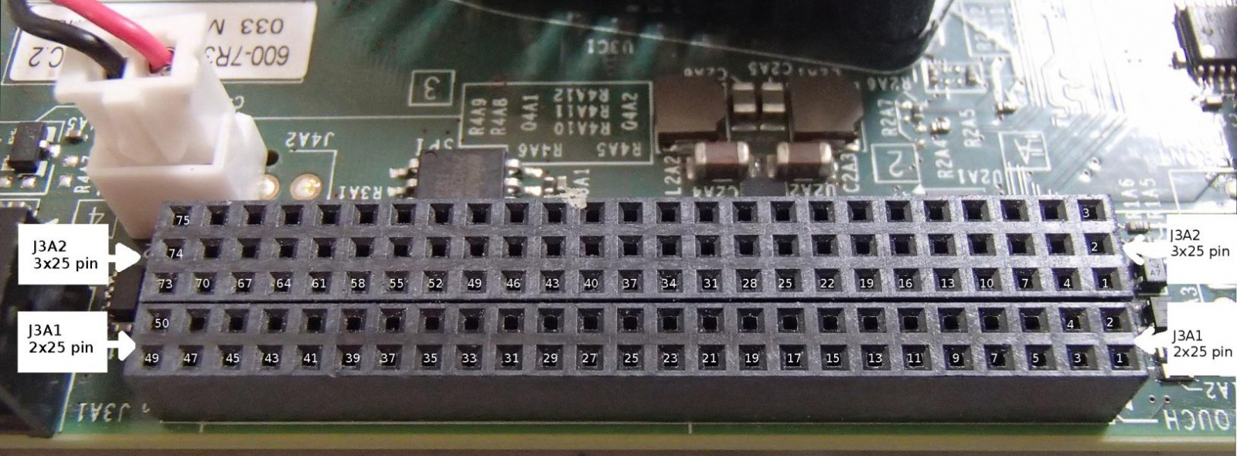

Figure 3. Image displaying the pin values of the Jetson’s GPIO.

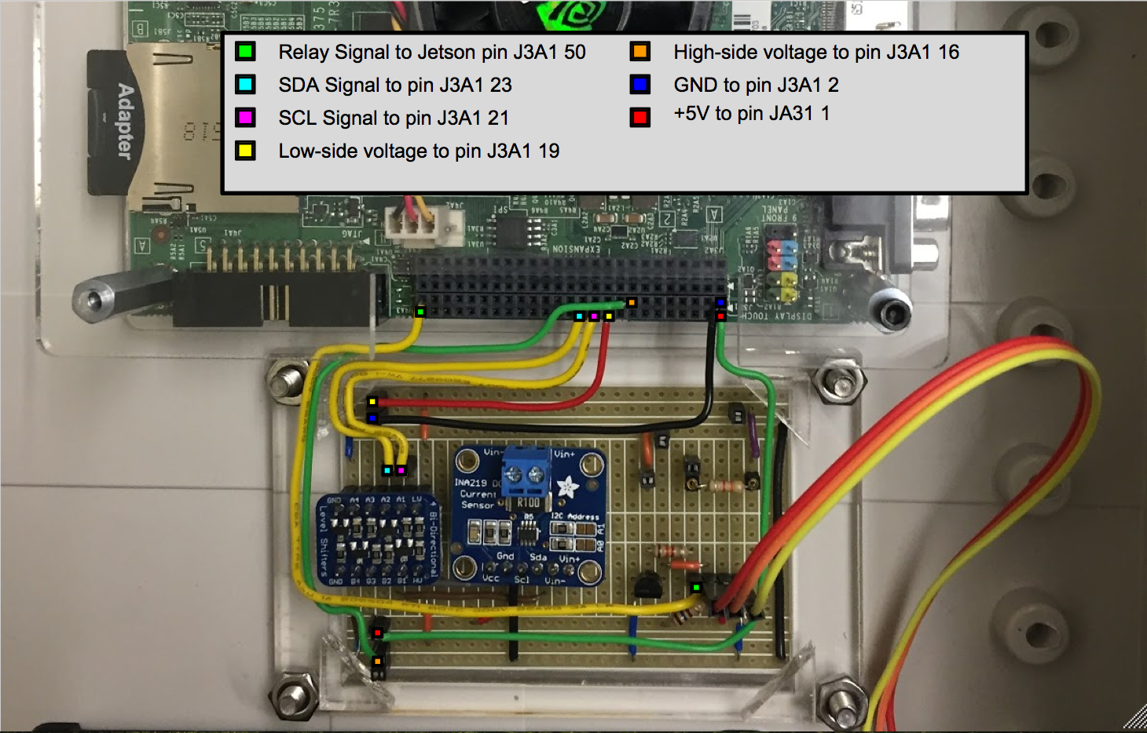

Figure 4. The connections between the circuit board and the GPIO.

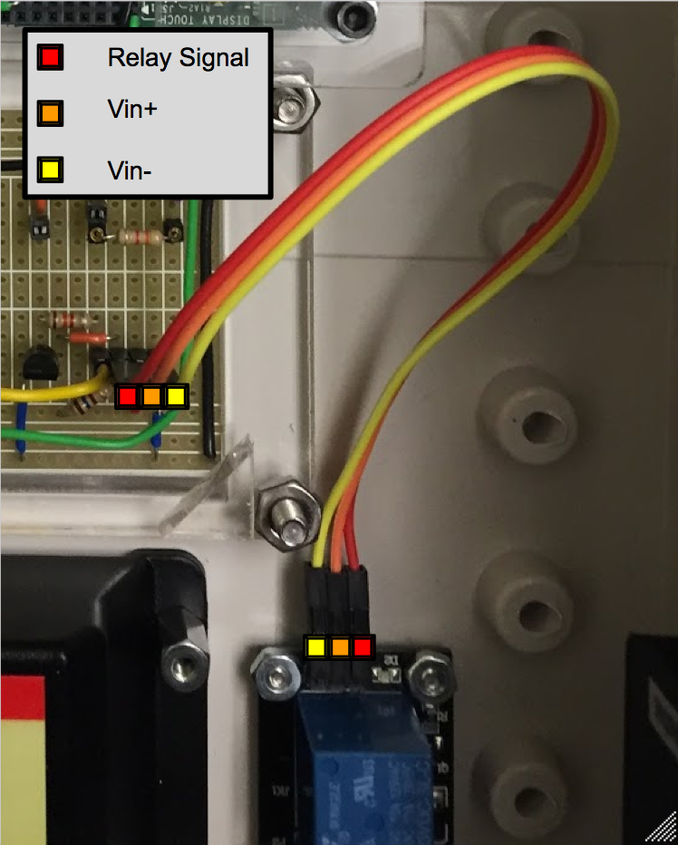

Figure 5. Relay connection to the circuit board.

The camera as well as the Wi-fi dongle are connected to the Jetson via the USB hub attached to the right interior side of the box.

For the demonstration, a life size alert sign was created out of cardboard and simple LEDs to substitute for the final sign. At the time of testing, the sign was not yet delivered so this was used in its place.

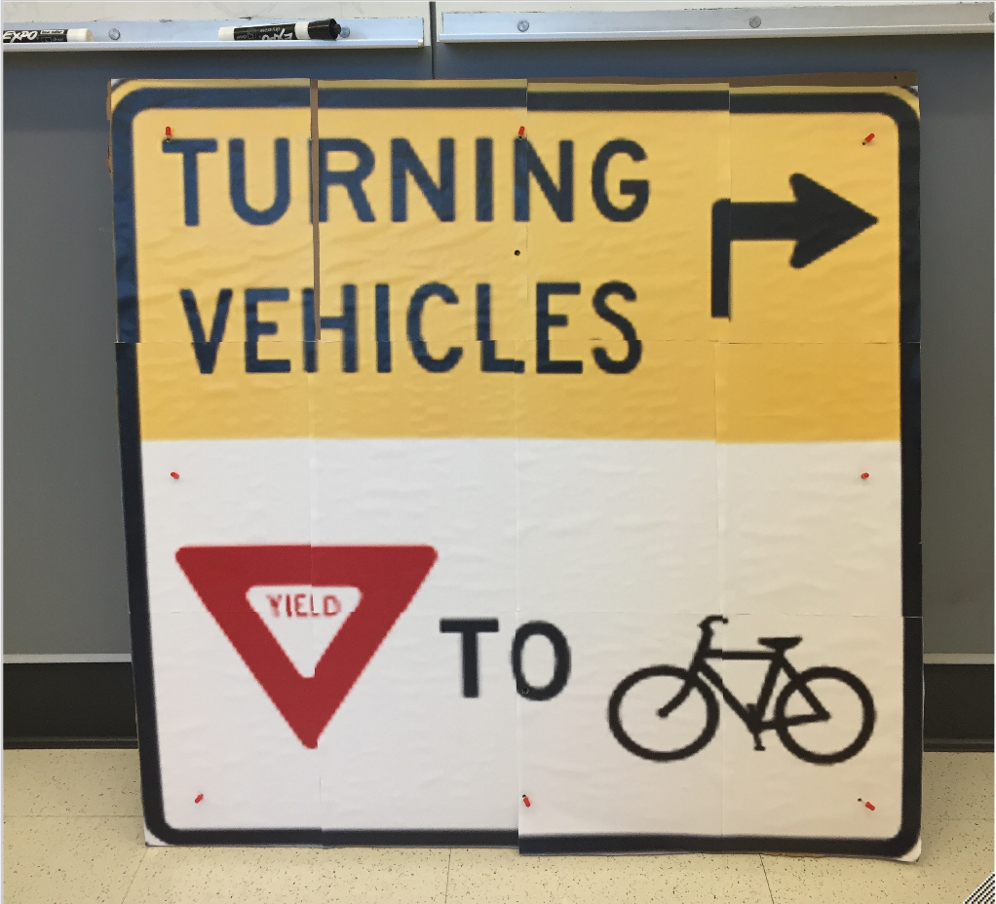

Figure 6. Picture of the temporary sign used for testing.

The RightAlert website is hosted on an AWS EC2 instance and provides access to many features either to monitor incoming data or control the hardware hub.

**1.2 Setup**

In order to test RightAlert in a realistic environment and scenario, setup for the test took place outside on 110 Cummington Mall, outside the door of the Department of Mechanical Engineering. To simulate how the system would be setup during customer installation, the camera inside the hardware hub had to be placed at an elevation of approximately 10ft. To do so, the enclosure was propped on top of a ladder which placed it at about 9ft in the air. The camera was pointed down Cummington Mall to catch a clear view of the whole street and all cars and bikes that came down. This simulates the final plan, being that the wide cement pole behind it will be its permanent home after installation.

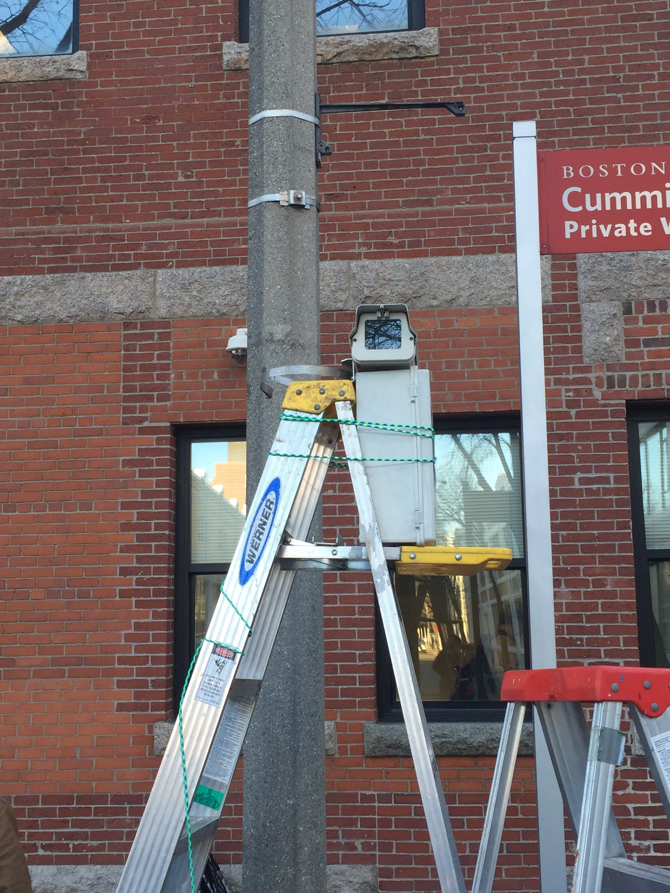 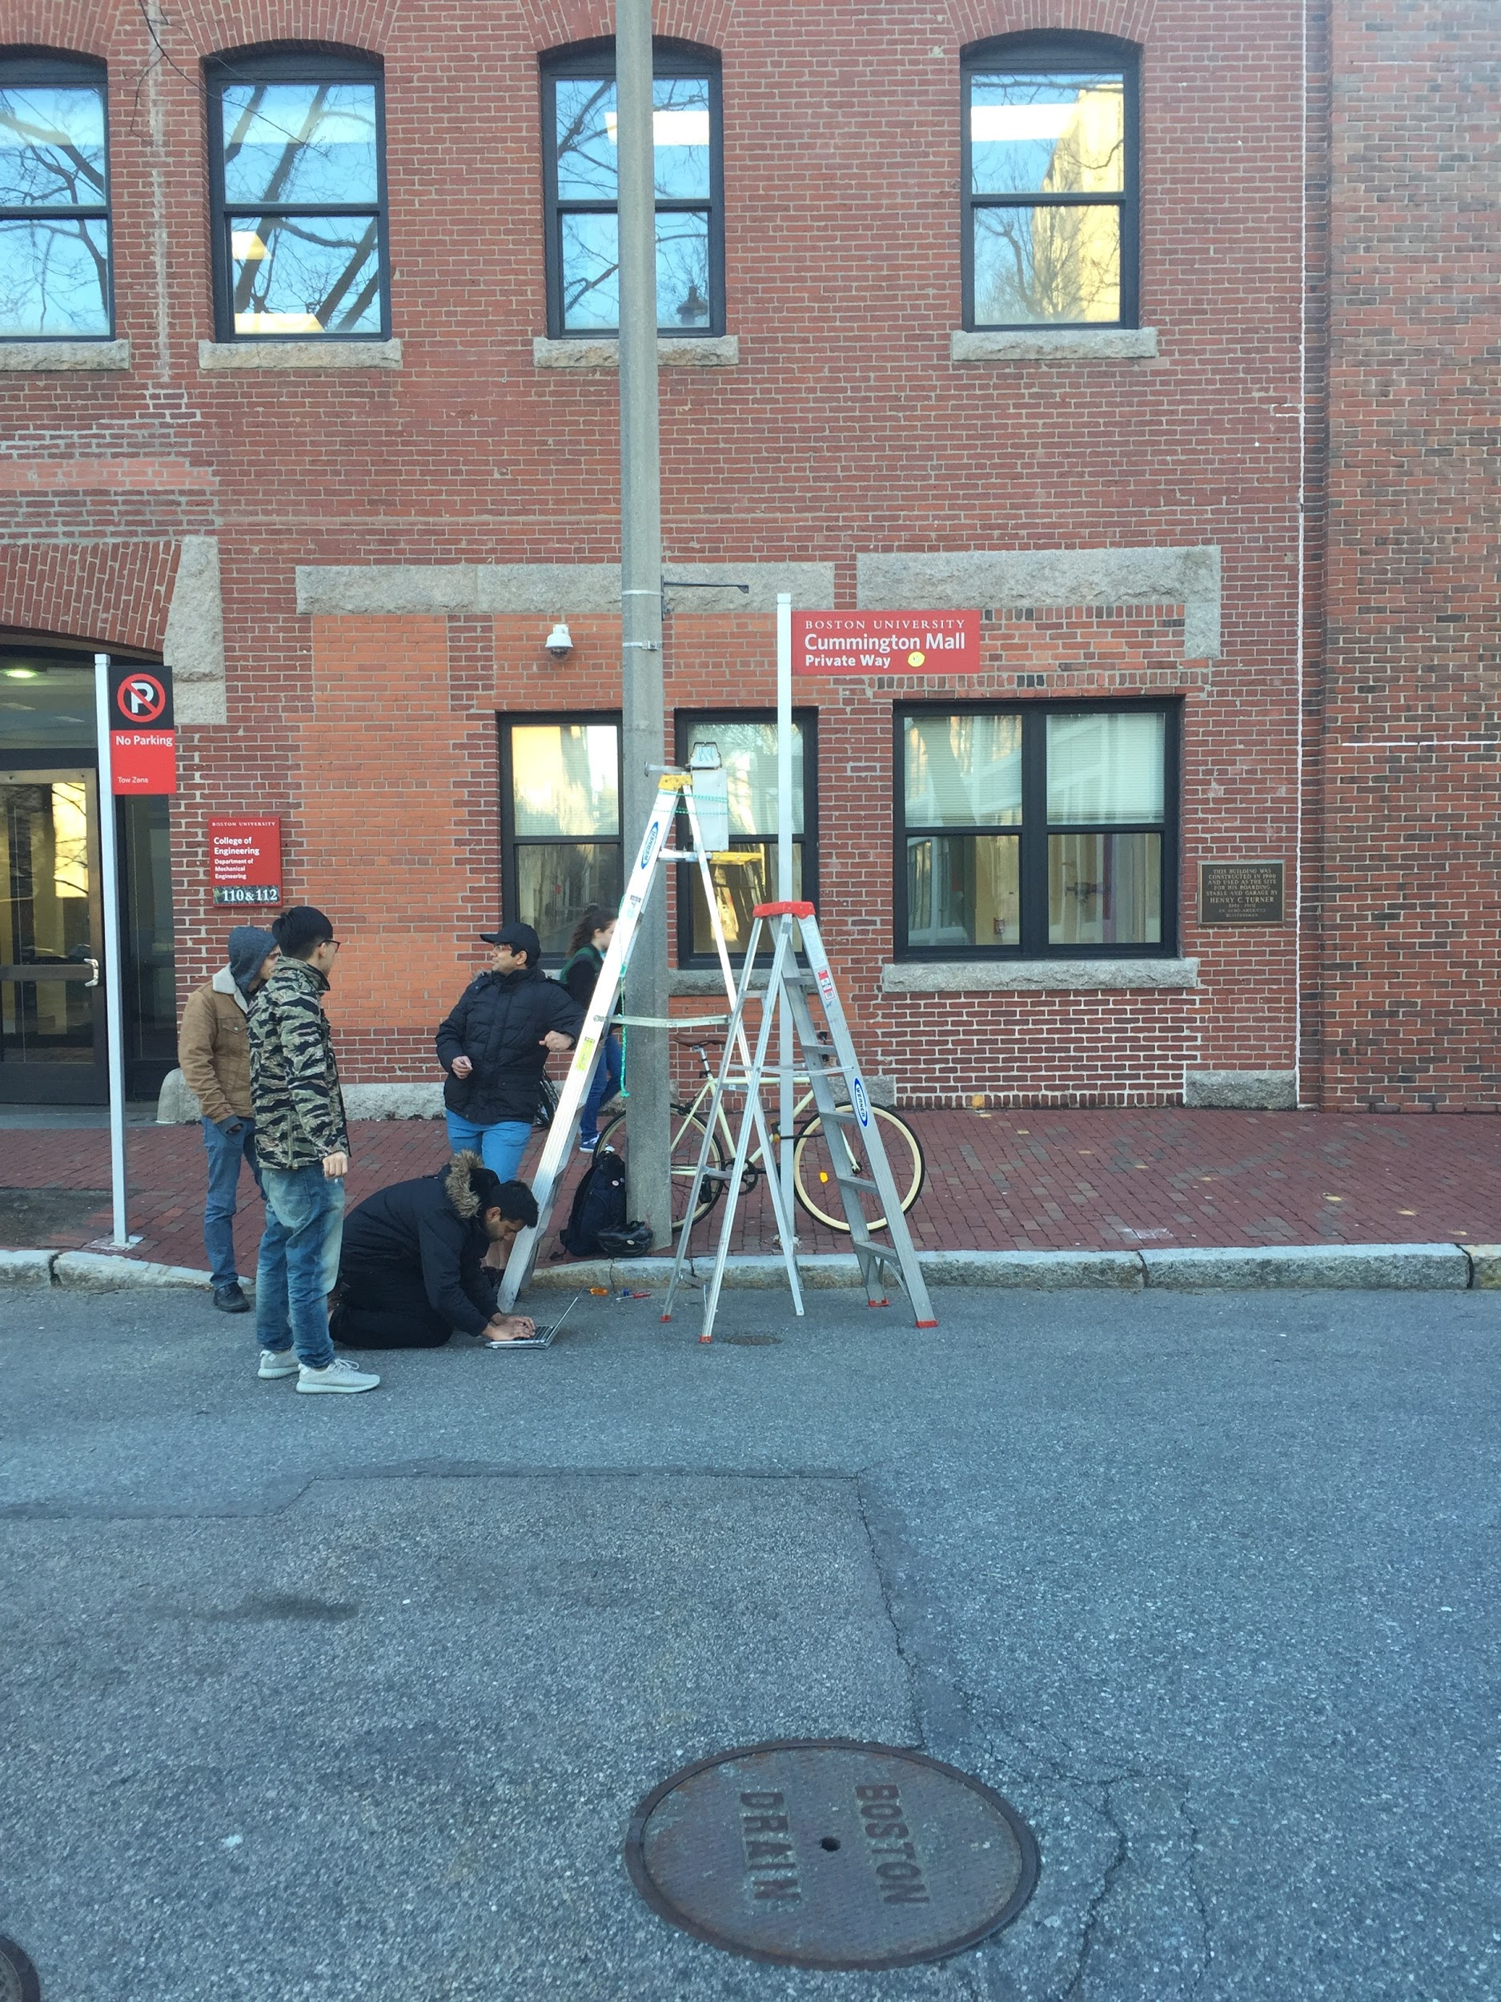

Figure 7. Hardware hub propped on the ladder. Figure 8. A view of the location of the ladder.

It is not shown in these pictures, however the substitute alert sign was connected to the power supply and relay circuit inside the enclosure with a long wire. During testing, the sign was rested on the floor pointed down Cummington Mall, like the camera. This was done for convenience. The final installation will have the LED lit sign mounted on the same cement pole as the hardware enclosure, a foot or so below it.

In order to upload data from the RightAlert system to the RightAlert website, internet connection was a necessity. As a result of the weak connection to the university’s wifi, the NVIDIA Jetson connected to a router placed near the entrance of the building behind the setup. This router was connected directly to BU’s wired network.

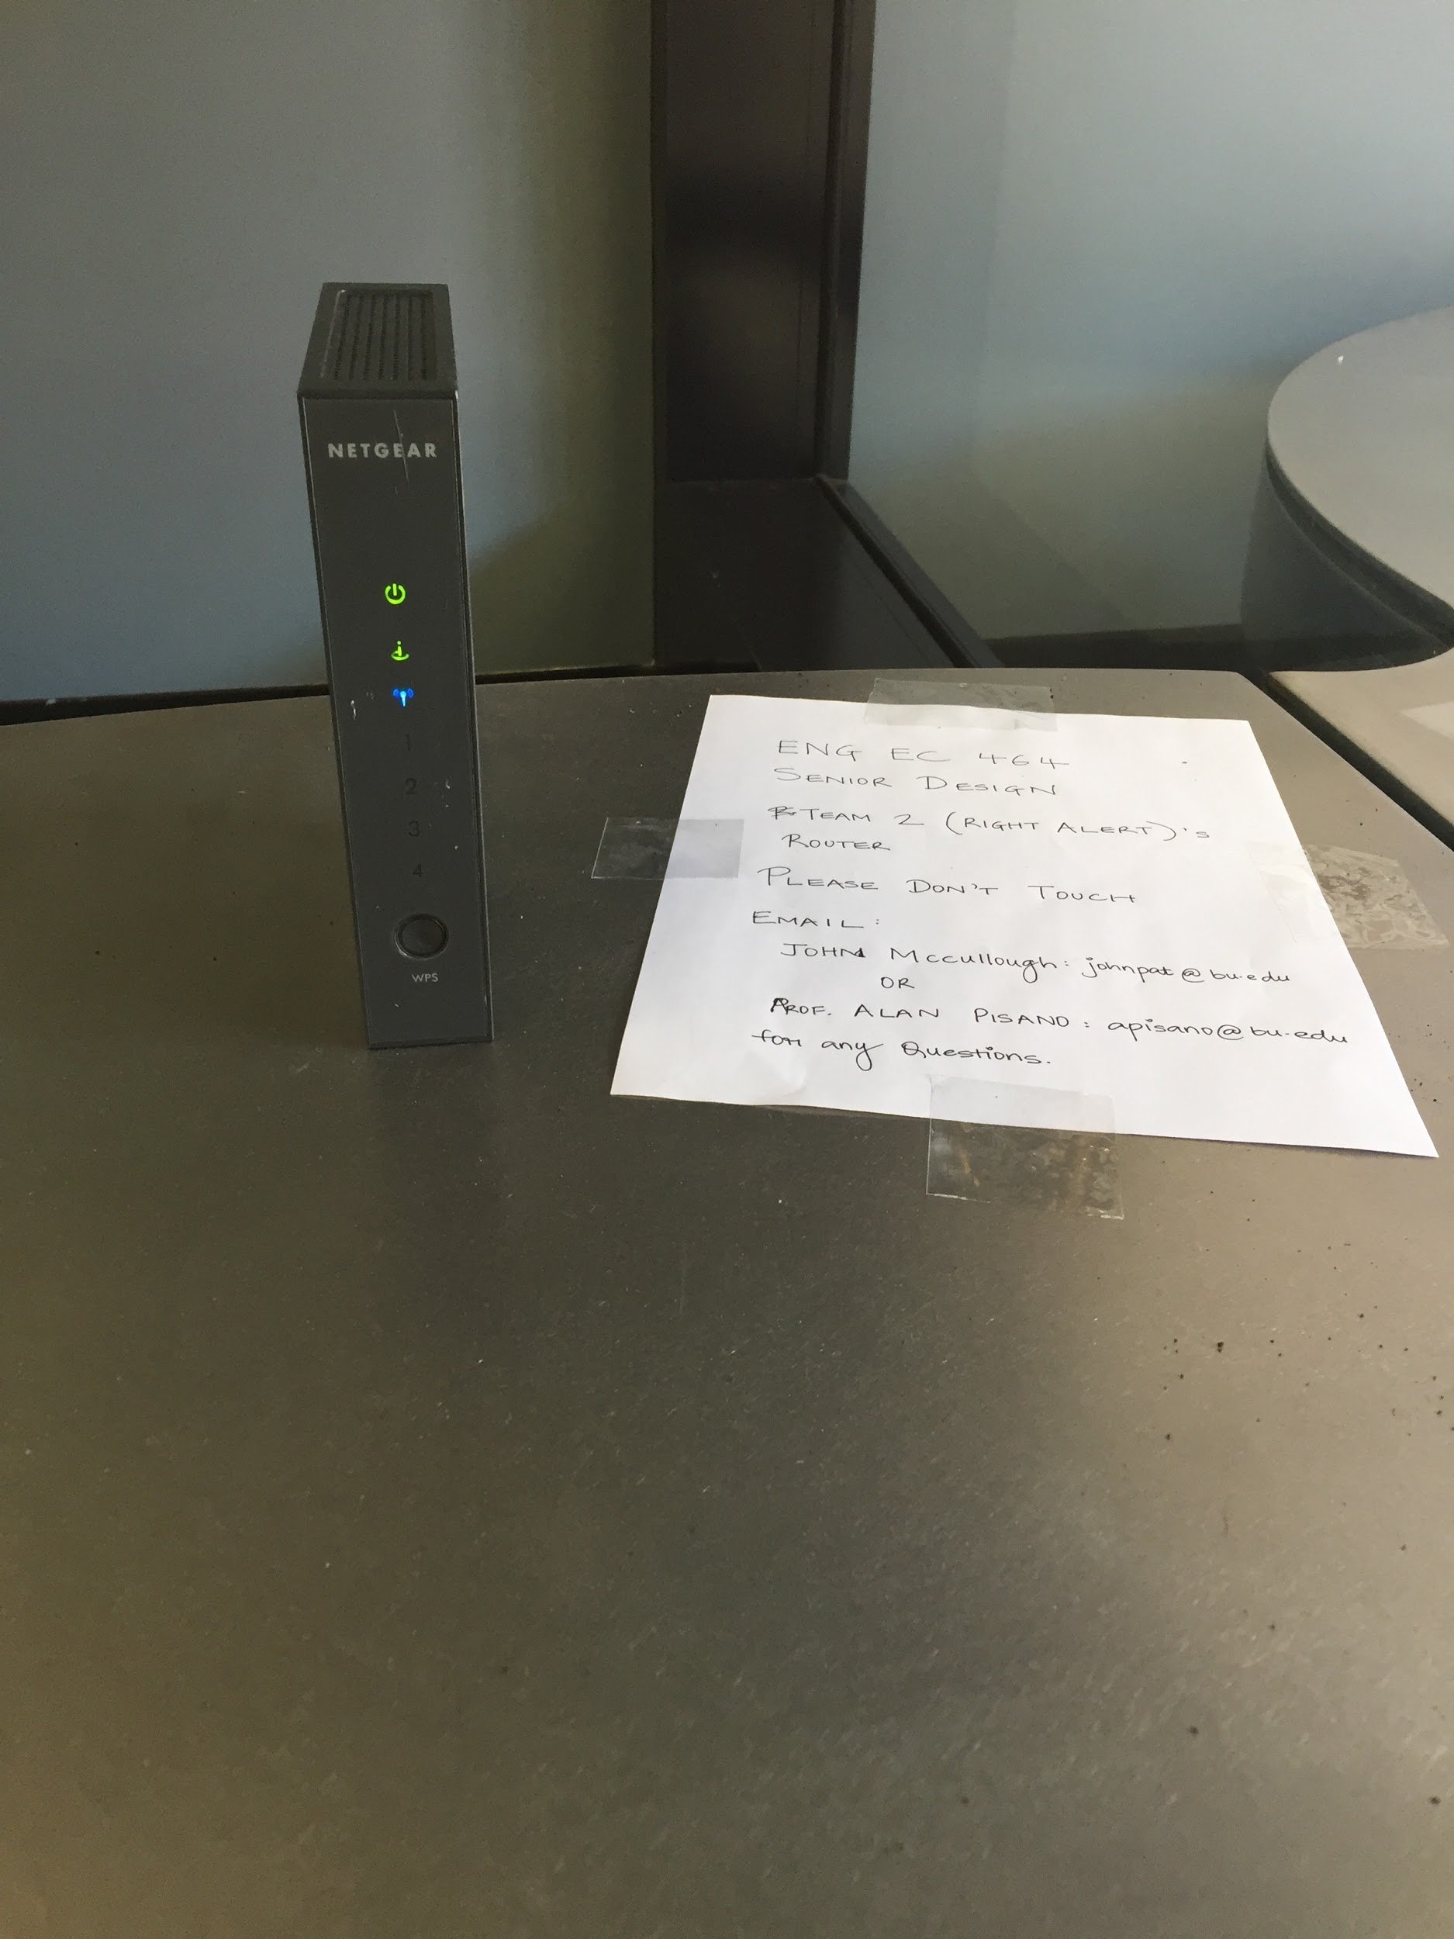 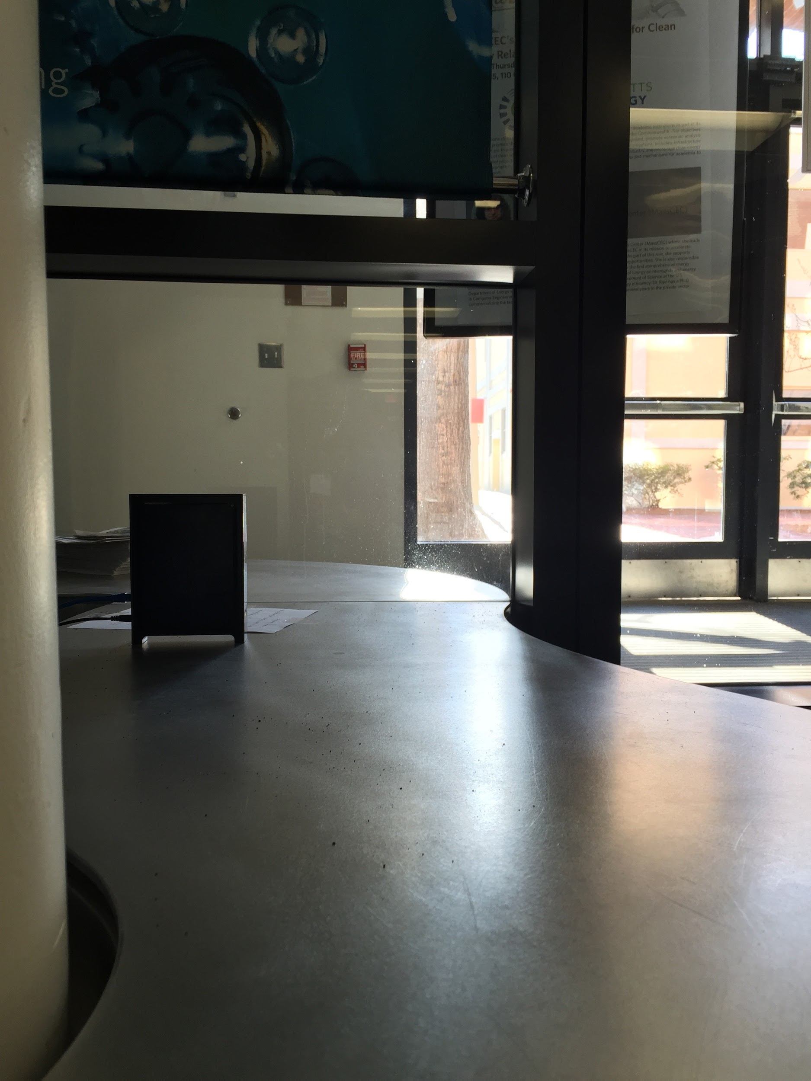

Figure 9. The router used for testing. Figure 10. The router in proximity to the door of the

Department of Mechanical Engineering.

**2.0 Bike Detection System**

**2.1 Bike Detection Algorithm**

*Description and Goal*

For bike detection we are using a Machine Learning Algorithm. The procedure trains an SVM classifier with positive and negative training images taken at the installation site (Cummington Mall). In order to provide an accurate detection rate, training images with rich differences were taken. The negative images must focus on objects that could have very similar HOG features to that of a biker, eg: people, tree trunks.

Currently, the algorithm has been trained with **556** positive and **1173** negative training images taken on Cummington Mall. In order to test the performance of this system we tested the predictions of this system for numerous different dataset combinations.

For the demonstration, we ran our algorithm on a live feed of Cummington Mall and observe its accuracy.

The goal of having a well-trained algorithm is to minimize the rate of false negative and false positive readings of oncoming bikers. The lower these rates are, the safer an experience we can guarantee drivers and bikers using an intersection that implements RightAlert.

*Measurements and Assessment*

Our code was set up to record the detections made during testing. We took the detections made for the video we ran it on and separated the false positive detections from the true positive detections. We then used these image false positive images as negatives for improving the classifier. We had a total of **67** detections, out of which **19** were false positives. During the re-training phase we had some issues. The problem was the limit for the number of negatives that we could use for training had been reached. So, we carefully edited the negatives folder and re-trained the SVM. We saw an improvement in the detection rate. The number of false positives dropped to **8**.

*Conclusion*

The results of the testing highlighted our prospective process of improving the SVM after installation at the destination. The process also highlighted the fact that there is a restriction on how much data we can use to train the SVM and also that there seems to be a logarithmic relation between the number of training images and the accuracy of the SVM.

**2.2 Algorithm Interaction with Alert Sign LEDs**

*Description and Goal*

In order to simulate our custom LED lit alert sign for the demonstration, we substituted a full-sized mock alert sign with embedded, standard red LEDs. While the detection algorithm is observing the test video, the LEDs will turn on everytime it has made a detection of what it believes is a biker. This test is to ensure the Jetson’s GPIO interact harmoniously with the OpenCV code it is running. This is an incredibly important portion of the alert system because it will be the visual cue drivers will use to stop for oncoming bikers.

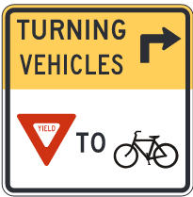 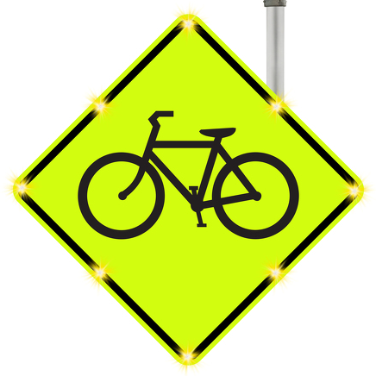

Standard MUTCD sign R10-15 (mod.) Example of TAPCO custom-made sign with 8 LEDs

that we will be using in real system affixed using ultrasonic welding

*Procedure*

The LEDs in the mock sign are connected in parallel in a simple circuit. Their positive ends are connected through a 510Ω resistor to pin50 of the Jetson and their negative ends are connected to GND on the Jetson.Since the LEDs are already connected to the Jetson’s GPIO, we need only to observe them when the algorithm has made a detection. When a biker is detected, we should expect the LEDs to turn on. When a biker is no longer detected the LEDs should turn off.

*Assessment and Conclusion*

The initial results of the mock alert sign were successful. When the algorithm detected a bike, it sent 12V that made its way through the mechanical relay powered the 8 LEDs to peak brightness, about 2.0V. We expected the real TAPCO-made alert sign would have been delivered by our testing slot, however, an error with a part manufacturer delayed its completion. Mounting and testing with the final sign will take place as soon as it arrives, including duty cycle control and observation of correct bike detection.

**3.0 Right Alert Administration Website**

*Description and Goal*

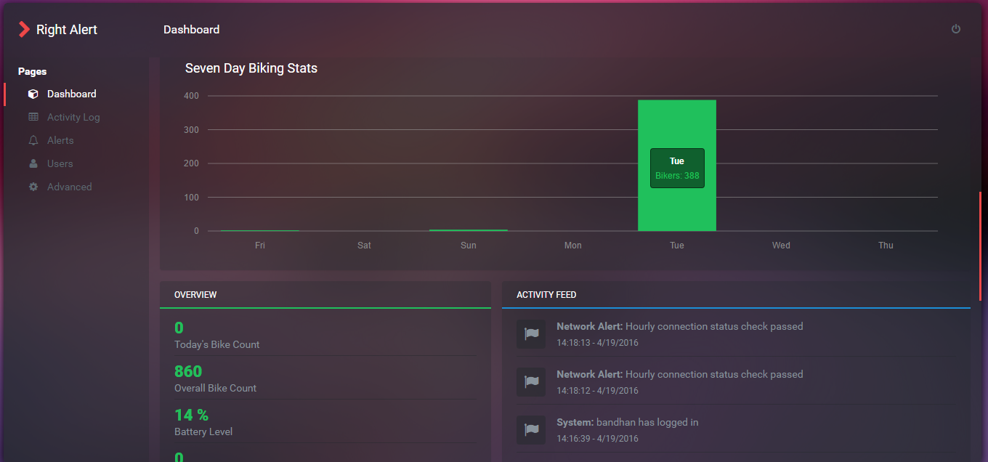

The RightAlert Website provided a central administration portal for the customer to view collected data, verify the system is working properly, and provide remote administration. Upon visiting <http://admin.rightalert.net> the user is asked to login. Administrators will be provided with a default admin account to login with. After successful login, the customer is presented with the homepage which displays a brief visual of recent data, an overview of current system information, and a live activity feed. The Overview section provides information such as number of bikers that have passed throughout the day, number of overall bikers that have passed since the system was implemented, and the RightAlert system battery level. The activity feed is a live reflection of a database which contains recent system events. The website is coded with C# and uses the ASP.NET framework.

As a test, we will verify that the activity feed/activity log page show accurate data reflected from real world events. Every time our system detects a bike, an alert should populate the activity feed stating that a biker is detected.

*Measurement and Assessment*

Similar to the LEDs, the algorithm’s update to the RightAlert website are automatic and rely on no input from the user. We will simply wait for the system to make a detection and observe if the website is updated. This procedure is used on the homepage for the bike counters, battery level, and the activity feed.

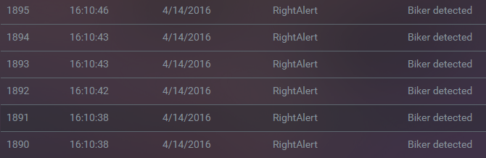

During our testing, we observed that there were instances when a biker passed that multiple detections were triggered. While one biker was detected in the frame, the algorithm would momentarily no longer detect the bike, and then if it redetected the same bike, it would count it as a new bike detection. For our system, this mistake can happen in less than a second as exemplified in the image above.

*Conclusion*

After the algorithm detects a bike, in addition to the LED lights, a script is run to update the SQL database and upload an image to AWS S3. By visiting <http://admin.rightalert.net> it can be confirmed that the database was updated with a record of a biker and the latest captured image is visible on the webpage. Further verification can be completed by direct view of database tables and local Jetson storage. We observed that the latest detection images provided by entry 1890 and 1891 are actually the same. This is an error of our system as one bike should only be detected once as it passes through an intersection. To resolve this from further occuring, the bike detection algorithm was updated to ensure that the same biker would not trigger an alert or database update repeatedly.

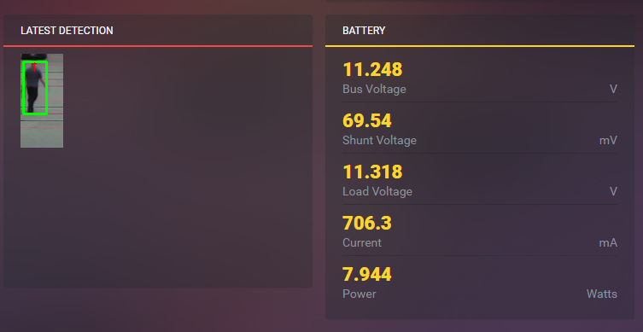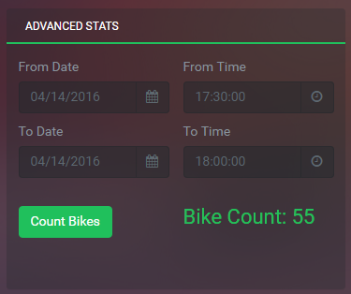

**4.0 Conclusion**

**4.1 Algorithm**

The current algorithm does a great job at bike detection, given a sufficient amount of training data and heuristic information. A true positive rate of 0.92 and a false positive rate of 0.02 puts us on a good spot on an ROC curve. However, this is not the end of it. There is scope for improvement and we aim to capitalize on it. One of the current issues is the speed of the detection but this can and will be optimized by using GPU programming.

**4.2 Website**

The website will allow both analysis and control of our final system. When the RightAlert system is mounted on the street, it is preferred to not have to physically touch the device unless hardware maintenance is required. The website will allow us to reboot the device, turn on/off the alert sign, turn on/off detection, etc. Depending on what data we are able to extract from our algorithm, the website will also serve as the portal where data from our system is visualized and analyzed to see our systems reliability and usefulness.

**4.3 Power Module**

The fully functional power module has been tested for supporting the entire system at daytime. Since the environment of location we test the solar panel and rest of the system does not meet the average sunshine hours in Boston area, we may not have maximum power output from solar panel. According to the monitor system on the website, our battery has been proven to support the system without the LED sign for 7 hours with 60% percentage of battery. When the battery voltage drops below 11.1V, which is also the minimum safety voltage in the battery, the system may not running thoroughly, so we set the threshold voltage of 11.1V to automatically shut down the entire system.